**Strategic and twitch skills**

Zakaria Ahmed

**1.1 Game Premise**

In a group, we created a game that required players to use images from the internet in order for other players to guess a word from said images. We had done this via google images and a wheel spin mechanic in order for the player to pick a generated word to show via images, incorporating social media into the mechanics to create a new way of playing. It was decided to do this as most people are familiar with charades and creating a spin-off would make for great experience when playing . Furthermore, rewards and penalty systems were implemented as well as rules to ensure the gameplay is what we had intended.

**1.2 Materials**

As the task requires players to use media to play the game, each player would have to bring in their own phone to ensure that the game can run as intended. Here are all the materials needed:

* A mobile device (phone recommended)
* Timer to keep track of time per round (https://www.online-stopwatch.com/)
* Wheel spinner to pick words for the players (https://www.online-stopwatch.com/random-name-pickers/name-picker-wheel/?r=MuRGyi1Hhb )
* Notepad document to record player scores as game progresses

**1.3 Rules/Mechanics**

Start by spinning the wheel in order to choose your topic.

Next start the 1 minute 30 second timer in order to select your images and show them to the other players.

The player may not use images that references the subject matter in anyway (I.E a scene from the movie)

If they guess correctly the player who guessed gets 1 point and the person who showed the images gets 1 point.

The first player to 5 points wins

Bonus- if the player acting that round did not break any rules (time limit and not using image references) then they may be given an additional point

Penalty- If they use minor references then they are only awarded 1 point, if they break the rules however they gain 0 points, the guesser still gains points

**Word picker mechanic:**

Here is the pre-set list created for the new starters of the game (See figure 1)

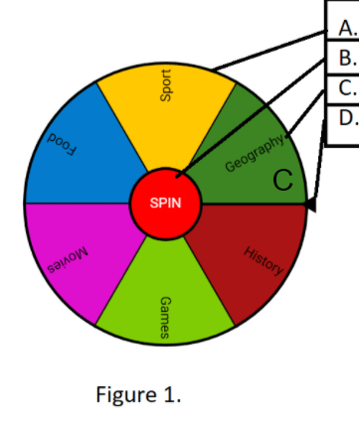

**“A” is the wheel spinner and spin by pressing the “B” button. All choices, for example “C” can be chosen and “D” is the choice picker when the wheel stops.**

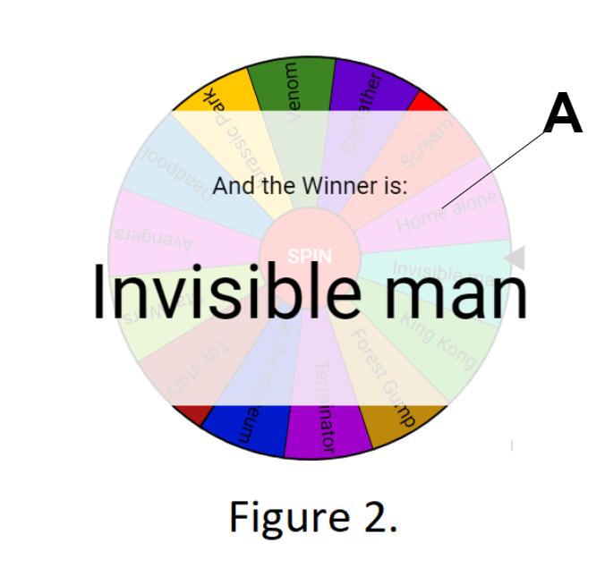

**“A” is displaying a possible outcome to the player after one instance of a wheel spin**

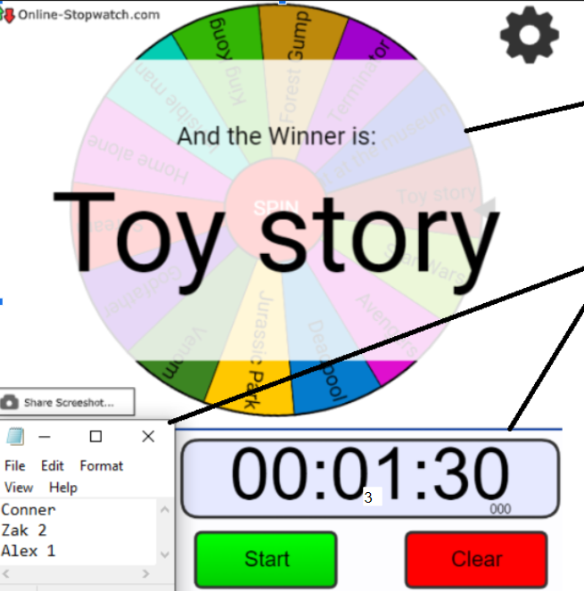

C

B

A

**Figure 3**

**Here is an example of how a game was played. The mechanic showed in “A” works as intended, displaying a word. We used a countdown timer over at “B” to time each round and “C” keeps track of current scores.**

**1.4 How the game is played**

External Playtesting:

“I like the fact that the games were quick and easy to understand”

External playtesting was done and the feedback was positive, players liked that the game was simple to understand and this was because it was similar to charades and made the game exciting to play.

**1.5 Teamwork/Reflection**

A common problem when working in groups was that one person only working on the presentation slide which was a limiting factor in development, many ideas tossed around but one person writing that would often slow down the pace. Our team had used different presentation software that allowed all of us to contribute to the presentation whilst being at separate desktops, this sped up work which later gave us time to smoothen out gameplay.

Team- Zakaria Ahmed, Connor Hadley, Stefan-Alexandru Zarnescu